DIVISION

TEMPLATES AND GUIDESFG

Blue Feed, or Position / Location Information (PLI) is critical to mission command and to the success of tactical formations, not only does it reduce the "fog of war" by affording situational awareness from the tactical edge to staff elements at the highest level. This feed is propagated via multicast routing.

Key: XX=Student Number (Example = 01)

Ensure multicast is enabled:

**!**

**configure terminal**

**!**

**ip multicast-routing distributed**

Ensure PIM is enabled on the student switch and router interfaces towards the source of the multicast stream.

On the Router:

**!**

**configure terminal**

**!**

**interface Tunnel 1XX**

**ip pim sparse-mode**

**!**

**interface g0/0/0.2XX**

**ip pim sparse-mode**

**!**

**interface vlan 1XX**

**ip pim sparse-mode**

**!**

**Interface vlan 2XX**

**Ip pim sparse-mode**

**!**

You can validate your configuration and functionality with the following set of commands:

**show ip pim interface**

**show ip pim neighbor**

**show ip pim rp-mapping**

**show ip mroute**

**show ip mroute count**

For troubleshooting you can use the command below to verify that you are requesting the multicast feed with a (*,G) in the mroute table. Additionally, you should see a (S,G) in the mroute table towards the source. This command in applied to the interface: **ip igmp join-group 225.0.0.255**

To gain access to the feed use VLC on your student desktop and follow the instructions below:

Step 1: Open VLC on Receiver and Select Open Network Stream.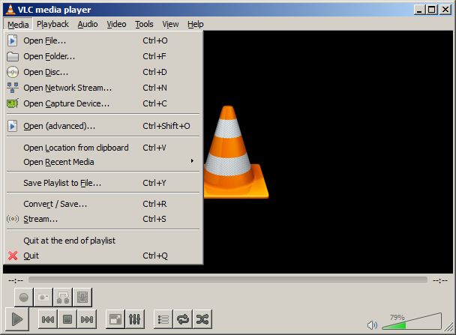

Step 2: Input rtp://@225.0.0.255:5004 and Select Play (Multicast Video should begin within 30 seconds)